Abdul Haseeb

20F-1066 | BSE-7A

DevOps Project

PHASe 02

**Report on Configuring Rocket.Chat**

# **Introduction**

This report contains all the steps that are required to run Rocket.Chat application locally on the machine. It highlights all the important learning aspects that are used in this configuration.

# **Configuration Steps**

## **Clone Repository from GitHub**

* Git clone <https://github.com/RocketChat/Rocket.Chat.git>

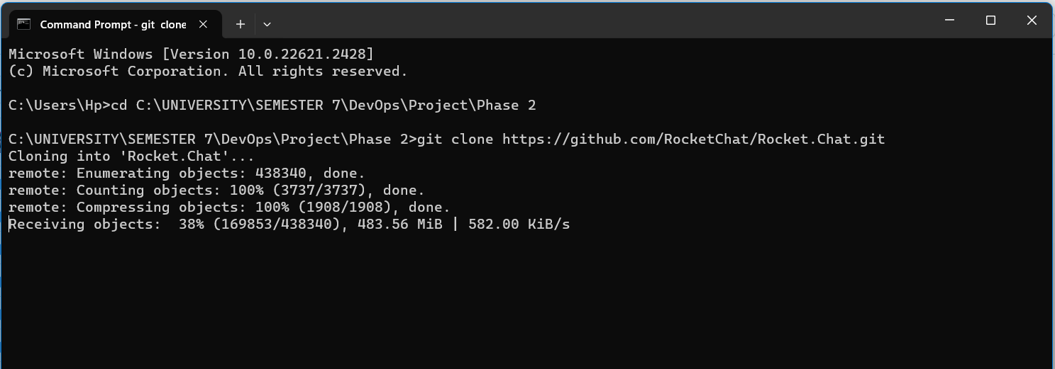

## **Installing Node**

Install node version 21.0.4 LTS for this configuration.

Used the following command:

* npm install node

## **Installing Meteor**

After installing node, we have to install meteor package using following command:

* npm install -g meteor

## **Installing Yarn**

For building all the packages, we would use yarn.

* npm install –-global yarn

## **Running the App**

Used the following commands to run the app:

* yarn run
* yarn dev
* yarn dsv